# Unit 8: Do we find goodness in acts of stewardship?

## Overview

There is an old saying, “Waste not, want not.” This means that if we use what we have carefully, and if we do not have excess, we will be content. From the opposite perspective, in the Bible, Ezekiel 16:49 refers to the city of Sodom: “She and her daughters were arrogant, overfed and unconcerned; they did not help the poor and needy.” In other words, living extravagantly while failing to help others was a sin. In this unit, we will consider the meaning of stewardship, its connection to justice and to the good life, and the question of our own actions and inactions.

## Prompts

Unit 8 will look at two kinds of prompts:

1: Case study of one organization: A Rocha

2. Digital media application challenges

## Learning Outcomes

Through practicing inquiry in this unit, you will:

* Examine and evaluate the meaning of stewardship and its relationship to justice and the good life.
* Analyze and investigate the principles and work of one specific environmental organization
* Analyze and synthesize various perspectives (from our class prompts and from classmates)
* Challenge yourself to evaluate your participation in stewardship activities and choices

## Activity Checklist

Here is a checklist of learning activities you will benefit from in completing this unit. You may find it useful for planning your work.

|  |  |
| --- | --- |
| 🗹 | **Activities** |
|  | Activity 8.1: Listen to Joni Mitchell’s “Big, Yellow Taxi.” Journal your response to the song. |
|  | Activity 8.2: Read the definition of stewardship and reflect. |
|  | Activity 8.3: Read the background information on A Rocha. |
|  | Activity 8.4: Go to the A Rocha Canada website and read the four guiding principles. |
|  | Activity 8.5: Watch the short video: A Rocha: Changing Lives. |
|  | Activity 8.6: Read the excerpts and respond. |
|  | Activity 8.7: Explore the websites for A Rocha Canada and A Rocha International. |
|  | Activity 8.8: Take the quiz from National Geographic: [Do you know how to go green?](https://www.nationalgeographic.com/environment/global-warming/green-lifestyle-quiz/) Then, go to [Green Eco Tips for Sustainable Living](http://www.globalstewards.org/ecotips.htm) and browse the many practical suggestions. |

**Assessment**

Here is the assessment for Unit 8.

|  |  |
| --- | --- |
| **Group discussion:** Do we find goodness in acts of stewardship?  With your group, discuss what the two application challenges in Prompt 2 show you about stewardship, justice, and the good life. | 2% |

## Prompt 1: Case Study of A Rocha

There are environmental organizations all over the world, each with a specific focus and a set of values that gives meaning to their activism. We will take a close look at one organization and spend some time getting to know its principles and work.

### Learning Activities

#### Activity 8.1: Listen and Reflect

Listen to Joni Mitchell’s classic song, “[Big, Yellow Taxi](https://www.youtube.com/watch?v=xWwUJH70ubM).” You can look up the lyrics if you would like to read as well.

Next, take approximately 5 minutes to journal your thoughts in response to the song.

#### Activity 8.2: Stewardship Discussion

Read the following definition of stewardship and reflect in your learning journal the question below. Feel free to share with your group when you meet this week.

According to the Miriam-Webster Dictionary, stewardship refers to “the conducting, supervising, or managing of something; *especially* **:**the careful and responsible management of something entrusted to one's care.”

* What kinds of things are entrusted to your care? What do you have that you need to learn to steward?

*Note that as with all of the first lesson prompts, you will* ***not be graded*** *on these discussions. This prompt will help you explore the topics and will be instrumental in completing the final project.*

#### Activity 8.3: A Rocha Case Study

Justice includes concepts of respect, equality, and fairness. It applies to human behavior, especially our treatment of others. When you have something, you are faced with a choice. You can choose to hoard it, use it for yourself, abuse it, care for it, apply it the needs of others, or give it away.

Think about how this choice intersects with justice.

The following will provide you with brief background information on A Rocha. Read this to set the context for your analysis.

**Background of the organization**

* A Rocha is a Christian conservation organization.
* It began as a movement in Portugal in 1982 and in Canada in the late 90s and TWU was a catalyst for this.
* Professor David Clements (TWU biology) was involved from the beginning.
* A key tenant of A Rocha is to be “planted” in a particular location
* A Rocha chose a location near TWU as the place to steward

**Philosophy of A Rocha**

* “Among “creation-care” organizations, which focus primarily on lifestyle change and political advocacy, A Rocha is known for our scientific research, hands-on conservation, sustainable agriculture and education programs” (A Rocha website)

#### Activity 8.4: Guiding Principles

Go to the [A Rocha Canada](https://arocha.ca/who-we-are-a-rocha-canada/why-the-christian-connection/) website and read the statements for the four guiding principles: love, obedience, justice and hope.

Consider how these four principles might guide you in pursuing stewardship, too. How can these four principles guide you in stewarding what God has given **you**?

#### Activity 8.5: A Rocha Video

Watch the short video: [A Rocha: Changing Lives](https://www.youtube.com/watch?v=hnY2ncsweeo), which highlights the different work of A Rocha and how it has impacted not just the ecosystem but also the people who volunteer. Consider the following questions:

* How do the lives of the people in this video change after becoming involved in A Rocha?
* Why is it that the human connection to nature seems to stir something deeper?
* What can you learn from the participants in A Rocha about our question, “What is the good life?”

#### Activity 8.6: Planted Reading and Response

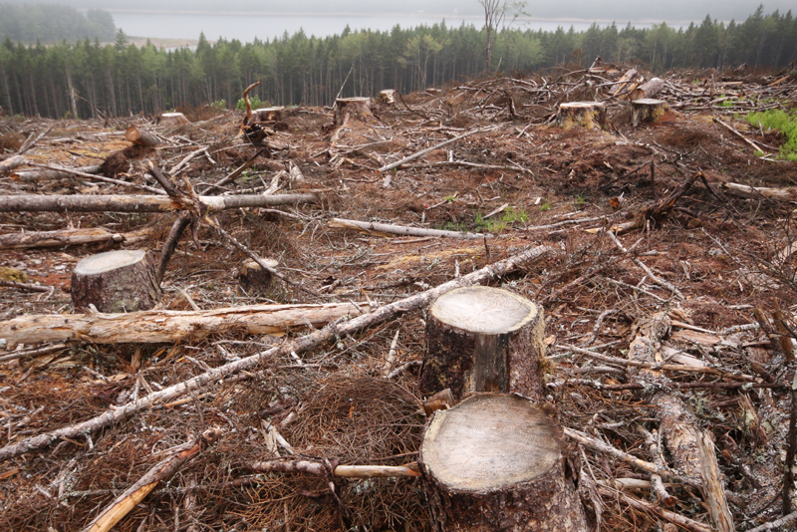

Figure 8.1: Image: Ecology Action Centre (from <https://ecologyaction.ca/press-release/poll-reaffirms-strong-public-support-clearcutting-crackdown>) **[****Check copyright]**

Leah Kostamo and her husband, Markku, were instrumental in founding A Rocha. She wrote a short book called *Planted*, which describes the stories and wonderings behind the organization. Read the short excerpts below and consider the questions that follow. Feel free to share your responses with your group when you meet this week.

|  |
| --- |
| Excerpt 1:  “…this is where the definition of ‘ecology’ is helpful: *eco* from the Greek oikos, for household, and *logia*, for ‘the study of.’ Anyone who has grown up in a household understands that it’s a complicated web of interrelated relationships. (If Mama ain’t happy, ain’t nobody happy, right?) In essence, the word *ecology* draws attention to the relationships between living things and their environment and implies that if one tinkers with one bit of the world, the effects are felt in radiating ripples throughout the rest of the world” (p. 7). |

Questions:

* Offer some examples of situations in which one part of the created world is touched and it impacted other parts. (Your example could be positive, towards restoration, or negative, leading to destruction).
* How do these kinds of situations intersect with the concepts of goodness and justice?

|  |
| --- |
| Excerpt 2:  “If ecology is the study of connections, then ecologists should be the first to rally against the injustices of environmental degradation and the subsequent human suffering that accompanies it. The reason why many don’t, as Peter Harris points out, is that we live in a time of complete disconnection. He writes, “products conceal their origins, academic disciplines operate in expert solitude, social relationships fragment.” But the poor do not have the luxury of disconnection from their environment. There are no presto logs to burn when their forests are decimated, no stashes of bottled water when the spring runs dry, no fertile fields around the bend when their crops sizzle during a prolonged drought” (p. 108). |

Questions:

* Offer an example of a place or people impacted by environmental injustice.
* How can this kind of injustice be avoided?
* What does this have to do with “the good life?”

#### Activity 8.7: Website Exploration and Discussion

Explore the websites for [A Rocha Canada](https://arocha.ca/) and [A Rocha International](http://www.arocha.org/en/). Look at some of the updates and stories to get a bigger picture of their acts of stewardship.

As you meet with your group this week, you may want to discuss what you gleaned from this online overview of A Rocha. How does A Rocha take action on stewardship? Do you agree with their approach? Do you disagree or question anything about the organization or their work?

Do we find goodness in stewardship? Discuss your conclusions.

## Prompt 2: Digital Media Application Challenges

#### Activity 8.8: Going Green

Take the short quiz from National Geographic: [Do you know how to go green?](https://www.nationalgeographic.com/environment/global-warming/green-lifestyle-quiz/) This quiz will hopefully get you thinking about whether you are on a path towards good stewardship and in what ways you waste.

Next, go to [Green Eco Tips for Sustainable Living](http://www.globalstewards.org/ecotips.htm) and browse the many practical suggestions. There are a lot of suggestions and challenges here, but as you skim, pause to consider some lifestyle changes (big or small) that you feel you could actually and honestly implement.

Finally, with your group, discuss what these two application challenges show you about stewardship, justice, and the good life. Complete the Discussion Template (your Google Doc) and post it.

## Assessment

### Group Discussion: Do we find goodness in acts of stewardship?

After completing this unit, including the learning activities, post the link to your Google Doc as a record of your group’s discussion of Prompt 2.

## Unit 8 Summary

Being a steward means being responsible and conscientious about how you use what you have been given, including the natural environment, finances, material goods, time, personal gifts and abilities. We haven’t been able to look at every aspect of stewardship, of course, but hopefully you have been challenged to think about how acts of stewardship fit into the good life.

## References

A Rocha Canada. (n.d.) Retrieved from <https://arocha.ca/>

A Rocha Canada. (2015, May 13). A Rocha: Changed Lives. Retrieved from <https://www.youtube.com/watch?v=hnY2ncsweeo>

Kostamo, L. (2013). *Planted: A story of creation, calling, and community*. Eugene, OR: Cascade Books.

Mitchell, J. (1970). Big, yellow taxi. *Ladies of the Canyon.* Retrieved from <http://jonimitchell.com/music/song.cfm?id=13>

Stewardship. (n.d.). Retrieved from <https://www.merriam-webster.com/dictionary/stewardship>